# **Plant physiology experiments, day 2**

Slaven Cvijetic, Lester Frei, Ali Rahmany, Basil Rast

**Abstract:** Several different experiments were conducted, regarding plant metabolism plant growth and plant hormone. To name just a few examples, the effect of auxin on different parts of plants was investigated. Another experiment, which investigated the different growth rate of different plants in light and dark conditions was conducted. A third experiment, concerning the detection of the gene, which encodes the green fluorescing protein.   
This string of experiments should lead to a better understanding of plants in general and to emphasise different crucial aspects of plant metabolism and plant hormone.

## Experiment C4.1, day 1 + 2: Polar regeneration of auxin-induced adventitious roots in hypocotyls of beans

### Introduction [1][2][3]

Auxin is a phytohormone, which has numerous important roles in the growth of plants. One effect of auxin is the promoting of cell elongation. The most frequent auxin in nature is Indole-3-acetic acid (IAA). IAA is present in all plants but only in small amounts (1 – 100 µg per kg plant material). It is made from the amino acid tryptophan at the tip of plants (shoot apex, root tip and young leaves) and then transported to the lower end of the hypocotyl. This is achieved by passive and active transport. If auxin is transported over a long distance, it happens basipetally (hypocotyl) or acropetally (roots) in the phloem. However, over short distances, symporters have an important role. IAA influences the growth of roots. If the concentration is higher than normal, the growth of primary roots is inhibited but the growth of adventitious roots reinforced. When the auxin concentration is lower than typical values, the whole root growth of a plant is decreased.

### Hypothesis

Adventitious roots will grow in the upper halves at the parts which had contact with the auxin solution. At the lower halves, which were in the auxin solution, the adventitious roots will grow at the hypocotyl. The seedlings which were placed in water, will not grow any adventitious roots.

### Methods [3]

* bean seedlings were cut in half
* cut seedlings were placed in water or auxin solution (0.01 mM IAA) for 2.5 hours (Figure 1)
* treated seedlings placed in petri dishes with wet filter paper
* petri dishes sealed up and kept dark
* growth phase of 1 week
* the growth of adventitious roots was analysed

Results

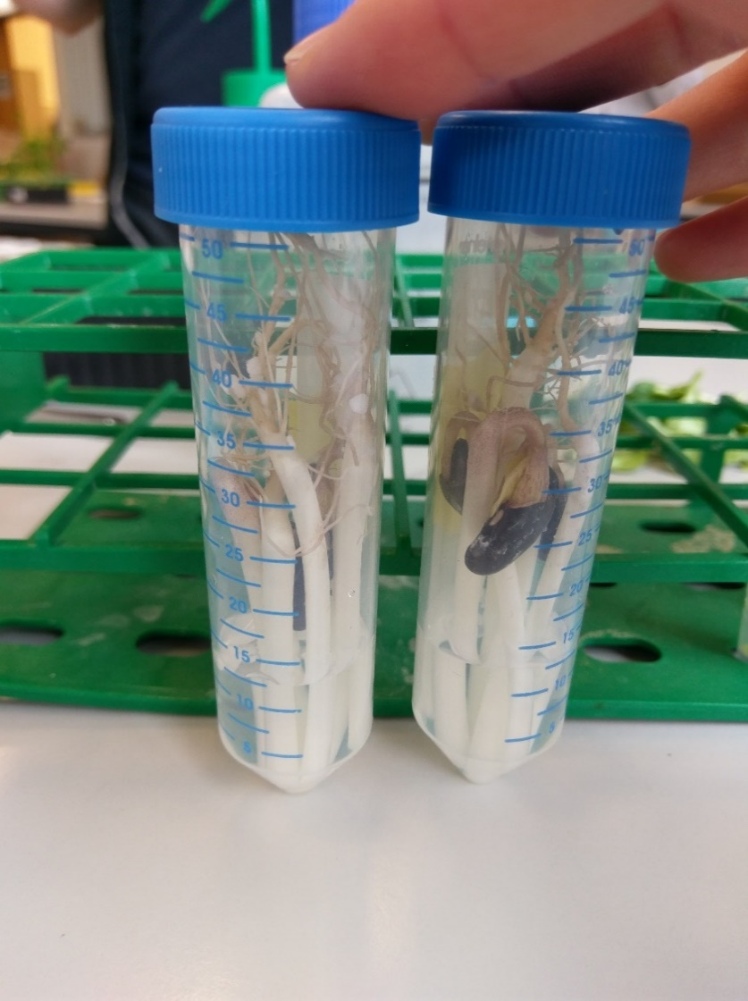

Figure 1: cut seedlings placed in water (left) and auxin

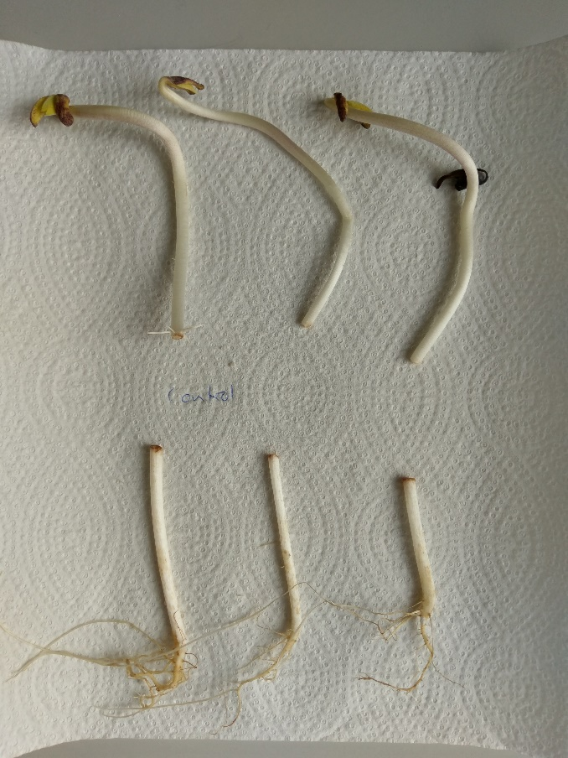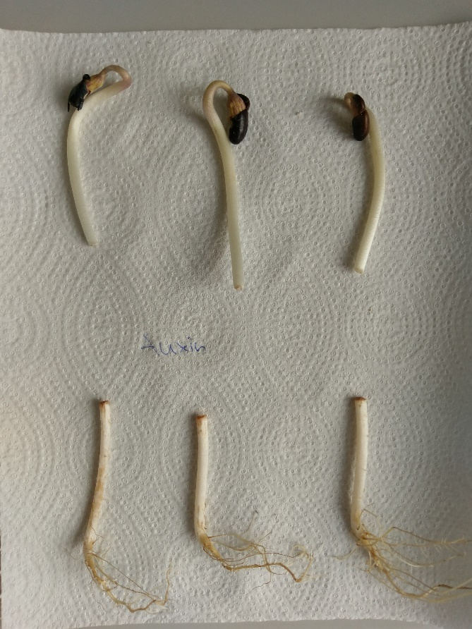The upper halves of the bean seedlings, which were placed in the auxin solution, had no adventitious roots after one week of growth (Figure 2). However, one of the upper halves bean seedlings, which was placed in water, had six adventitious roots (Figure 3).

Figure 3: bean seedlings, which were placed in the water, after one-week growth phase

Figure 2: bean seedlings, which were placed in the auxin solution, after one-week growth phase

Two of the lower halves of the bean seedlings, which were placed in the auxin solution, had adventitious roots (figure 2). Also, one of the lower halves, which was placed in water, had adventitious roots (figure 3). The other lower halves didn’t have any adventitious roots.

### Discussion

The results are not as expected. For the upper halves which were placed in auxin it was expected that some adventitious roots will grow. This was not the case. A possible explanation for this observation is, that the concentration of auxin was too high, which led to an inhibition of the root growth. The fact, that one of the upper halves, which was treated with water, grew adventitious roots, supports this explanation, because this seedling should have had a lower concentration of auxin.

The lower halves of the bean seedlings showed a minor difference in the growth of adventitious roots between the two treatments: The ones which were treated with auxin solution grew slightly more adventitious roots, which was expected by virtue of the growth promoting effect of auxin.

The difference between the upper and lower halves can be explained by the fact, that the tip of the upper halves produced more auxin than the root tips of the lower halves. This led to a higher concentration of auxin in the upper halves, which caused the inhibition of growth.

The concentration of cytokinin was independent of the treatment. Because of that, no statement about the influence of cytokinin on the growth of adventitious roots is possible.

To improve the experiment, the auxin concentration should be changed to a lower value or the time of the treatment should be shorter. Then the auxin should not have a negative effect on the growth of adventitious roots and the effect of auxin could be better investigated.

Experiment C4.3, day 1+2: Comparison of development in light and dark

## Results

## **Pea (control) in cm Pea (dark) in cm Barley (control) in cm Barley (dark) in cm**

|  |  |  |  |
| --- | --- | --- | --- |
| 2.6 | 4.5 | 8.4 | 4.0 |
| 3.4 | 5.3 | 8.5 | 4.4 |
| 2.1 | 3.6 | 5.8 | 8.4 |
| 2.1 | 3.9 | 4.5 | 10.5 |
| 3.6 | 4.3 | 7.5 | 8.1 |
| 2.7 | 3.2 | 7.2 | 9.0 |
| 3.4 | 4.5 | 8.4 | 7.0 |
| 2.5 | 4.2 | 7.8 | 7.2 |
| 2.4 | 4.6 | 7.4 | 10.0 |
| 4.7 | 4.4 | 9.0 | 8.5 |

*Table 1.*

The mean length of pea grown in the light (control) is 2.95 cm (Table 1), while the mean of pea (dark) is 4.25 cm. The relative increase in growth length is 44.06%.  
The mean of barley (control) is 7.45 cm. The mean of barley (dark) is 7.71 cm. The relative increase in growth length is 3.5 %.

## Discussion

There was a great increase in light deprived pea plants compared to the control group, but only a slight increase in light deprived barley plants. The results suggest that genetic factors play a more important role in growth of barley plants than in pea plants. This could be subject to future investigations.

Experiment C4.4, day 2: Analysis of norflurazon effect on plant growth

Introduction

Plant growth can be divided in two phases. The growth of a seedling after germination under soil is called skotomorphogenesis. The growth that takes place, once the growing plant penetrated the soil and reached the surface, is called photomorphogenesis.

The germination of seedling requires a number of factors including water and light. Seeds that did not receive a sufficient amount of light cannot go through the irreversible process of germination. As a result, light is a crucial factor in both phases, skotomorphogenesis and photomorphogenesis. [1]

Norflurazon is a non-selective herbicide. [5] It prevents the conversion of light into chemical energy through photosynthesis and it is prohibited to use in agriculture in Switzerland. [6] The aim of this experiment is to analyze the influence of norflurazon in combination with multiple light intensities on plant growth.

Hypothesis

As mentioned above, light is crucial for growth and germination. As a result, the seedling, which are going to be irradiated with low light, should neither germinate nor grow because we assume that there is not sufficient light in this case. Plants that were treated with Norflurazon should not grow either because this herbicide does not allow photosynthesis to take place. To sum up, only plants that were watered and irradiated under strong light are expected to grow.

Methods[1]

Five black trays were filled with vermiculite up to a height of about 4 cm. Four of these trails were labelled as follows: 1) lowlight + water; 2) lowlight + norflurazon; 3) strong light + water; 4) strong light + norflurazon. All the trays were then given enough tap water to soak the vermiculite. In each of the labelled trays, 20 mustard seeds were placed and afterwards covered with a layer of a about 1 cm of vermiculite of the unlabeled tray. The filled trays were separated into 2 groups depending on whether they were treated with norflurazon or water. The group which was treated with 150 ml of 2 µM norflurazon and the one which was irrigated with distilled water were both handed to the assistant.

# Experiment C4.2, day 1 + 2: Comparison of internodal growth of dwarf and normal pea

### Introduction [1][2][3]

Peas *(Pisum sativum*) have been cultivated by humans for a long time. And hence a plethora of varieties exist. Two of them are “Douche de Provence” and “Rapido”, which are used in this experiment. “Douche de Provence” peas belong to the dwarf peas, which are smaller than normal pea plants due to a mutation.

The growth of plants is influenced by gibberellins like gibberellic acid (GA3). Gibberellins belongs to a great family of tetracyclic, diterpenoid growth regulators. A higher concentration of GA3 results in excessive organ elongation. The effect of GA3 on the growth of plants was already found in 1938, when a rice plant was infected with a fungus. The fungus produced GA3, which led to an excessive growth of stems. The increasing of the volume of the plant organs due to GA3 is achieved by cell expansion and higher cell division rates.

### Hypothesis

The normal peas will show a difference in growth of the internodes, due to the different treatment (GA3/control). The dwarf peas will not show a difference in the growth of the internodes due to the treatment.

### Methods [1]

* internodes of 5 plants of each different treatment were measured and marked
* plants were sprayed with control or GA3 solution
* plants were grown for 1 week
* internodes were measured again

### Results

|  |  |  |  |  |  |  |  |  |
| --- | --- | --- | --- | --- | --- | --- | --- | --- |
| Plant/ Internode | Length internodes, normal pea, before GA3 treatment [mm] | Length internodes, normal pea, after GA3 treatment [mm] | Length internodes, normal pea, before treatment [mm] | Length internodes, normal pea, after control treatment [mm] | Length internodes, dwarf pea, before GA3 treatment [mm] | Length internodes, dwarf pea, GA3 treatment [mm] | Length internodes, dwarf pea, before treatment [mm] | Length internodes, dwarf pea, control treatment [mm] |
| 1/1 | 45 | 45 | 51 | 55 | 18 | 18 | 23 | 23 |
| 1/2 | 50 | 50 | 55 | 57 | 12 | 19 | 16 | 21 |
| 1/3 | 35 | 60 | 25 | 73 | 12 | 14 | 15 | 18 |
| 2/1 | 37 | 40 | 55 | 55 | 19 | 19 | 20 | 20 |
| 2/2 | 42 | 46 | 50 | 52 | 12 | 22 | 16 | 16 |
| 2/3 | 31 | 78 | -- | -- | 14 | 16 | 13 | 14 |
| 3/1 | 36 | 36 | 52 | 52 | 17 | 18 | 19 | 19 |
| 3/2 | 49 | 49 | 48 | 49 | 13 | 22 | 14 | 18 |
| 3/3 | 33 | 69 | 35 | 80 | 13 | 14 | 14 | 21 |
| 4/1 | 41 | 41 | 54 | 54 | 22 | 26 | 20 | 20 |
| 4/2 | 52 | 52 | 42 | 46 | 17 | 29 | 13 | 16 |
| 4/3 | 22 | 71 | 53 | 77 | 9 | 15 | 12 | 14 |
| 5/1 | 43 | 50 | 52 | 52 | 20 | 20 | 22 | 22 |
| 5/2 | 63 | 63 | 48 | 54 | 15 | 18 | 11 | 18 |
| 5/3 | 23 | 84 | -- | -- | 16 | 16 | 12 | 15 |
| Average internode 1 | 40.3 | 42.0 | 52.6 | 53.6 | 18.0 | 19.0 | 20.6 | 20.6 |
| Average internode 2 | 50.3 | 50.3 | 48.6 | 51.6 | 13.3 | 21.0 | 14.3 | 17.3 |
| Average internode 3 | 29.0 | 72.6 | 37.6 | 76.6 | 13.0 | 15.0 | 13.0 | 15.6 |

Table 2: measured length of internodes of all the studied plants. Average values calculated without highest and lowest values (exception: internodes normal peas, control treatment).

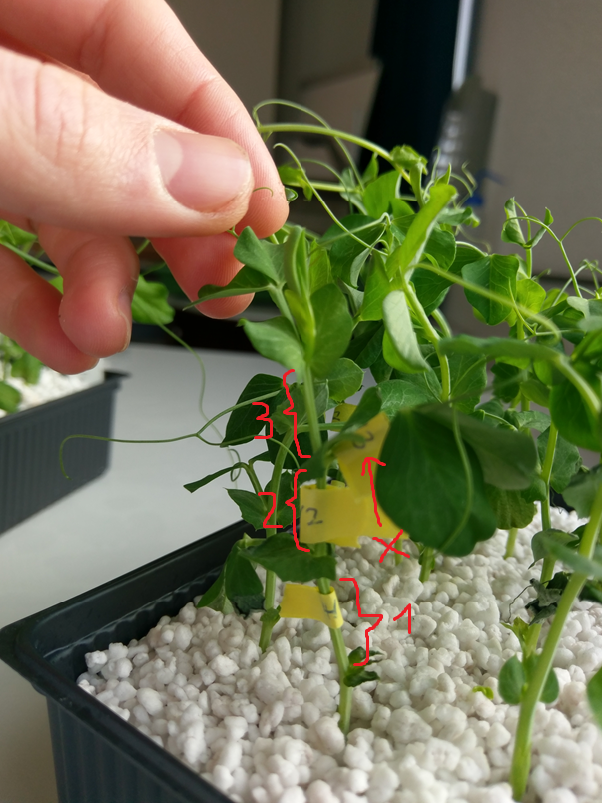The differences between the average length of the internodes 1 and 2 before and after treatment are not large. The internodes 3 of the normal peas showed large differences in the length before and after the treatment, but the ones of the dwarf peas not (table 1). This is because the nodes were measured instead of the internodes 3 (figure 1). So, the internodes 3 of the dwarf plants were measured only after the treatment (table 2). There was a great difference between the peas treated with GA3 and those which were treated with water.

Figure 4: dwarf pea plant with marks at the measured internode 1 and 2 respectively node, internode 3 wasn’t measured at the beginning

|  |  |  |
| --- | --- | --- |
| Plant | Length internode 3, dwarf pea, GA3 treatment [mm] | Length internode3, dwarf pea, control treatment [mm] |
| 1 | 60 | 19 |
| 2 | 48 | 13 |
| 3 | 50 | 22 |
| 4 | 83 | 16 |
| 5 | 48 | 11 |
| average length | 52.6 | 16.0 |

Table 3: measured length of the internodes 3 of the dwarf peas. Average values calculated without highest and lowest values.

### Discussion

It is difficult to compare the different peas and treatments altogether because the data of the dwarf peas are not complete. However, the data shows, that the dwarf peas have greater differences in the length of the internodes 3 due to the treatment than the normal peas. So that means, that GA3 has a stronger effect on the dwarf peas. But that’s not necessarily true, because it could be, that the difference in the length of internodes 3 of the dwarf peas was already there before the treatment only this wasn’t measured.

Generally, it can be said, that a treatment with GA3 leads to a higher internode growth. All the internodes which were treated with GA3 have a higher difference between the average internode length before and after the treatment than the internodes which were treated only with water. An exception is the average length of the internodes 2 of the normal peas.

It is not possible to say, which internodes showed the strongest response to the treatment due to the lack of data. So, when the experiment would be done again, the dwarf peas should be allowed to grow for a little bit longer. Then the identification of the internodes is easier and the error rate should be lower.

Experiment C31.3, day 2: Chromatographic separation of photosynthetic pigments

Introduction

Light is a crucial environmental factor which determines the development of plants in a variety of ways. It plays an important role in photosynthesis, the conversion of light in chemical energy in chloroplasts. Photosynthesis consists of two pathways, the light reaction that depends on sunlight and the dark reaction.[1] The absorption of light during the light reaction of photosynthesis takes places in the photosystems of the chloroplasts, which contain among other things pigment molecules like chlorophylls, carotenoids and phycobilines.[7] These pigments are associated to integral membrane protein of chloroplasts and are of amphiphlic nature.[8]The polarity of these pigments differ nonetheless because of the number of hydroxyl groups in each molecule. In this experiment, we use this fact in our favor to analyze and separate the pigments through a simple chromatography of processed pea leaves.

Hypothesis

This experiment verifies the existences of different photosynthetic pigments by chromatography using the different characteristics concerning the polarity of the pigments. In conclusion, we expect a number of bands.

Methods[1]

* Pea leaves (2 g) were mortared together with CaCO3 (neutralizing acidity)
* 50 ml acetone and 5 ml benzine were added
* After filtration, the solution was added to a separating funnel
* Liquid – liquid extraction with acetone and 10% NaCl (50 ml, 1 time) or distilled water (2 times)

🡪 for the second step accidentally soap water was used, that slowed down the extraction, but the extraction could still be completed

* Product of extraction was dried with Na2SO4
* Thin-layer chromatography (eluent: 100 ml petroleum ether/ 50 ml acetone)
* Selection of pigment for spectroscopy

🡪 carotene was selected

* Carotene was solved in hexane and then analyzed by spectroscopy

Results

The photosyntetic pigments were separated by the thin-layer chromatography (Figure 1). The separation of the pigments, which had an Rf below 0.4 was not very effective.

The result of the spectroscopy of carotene is shown in figure 2.

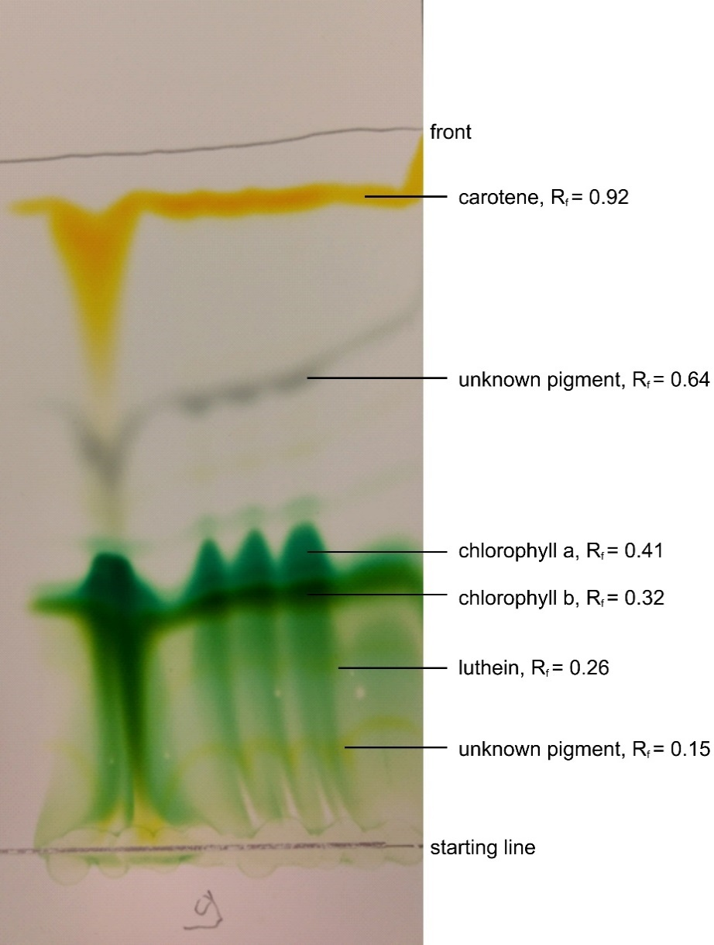

Figure 5:Result of the thin-layer chromatography

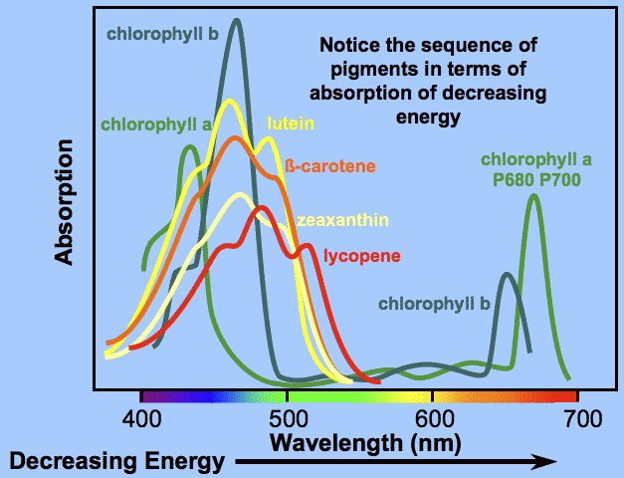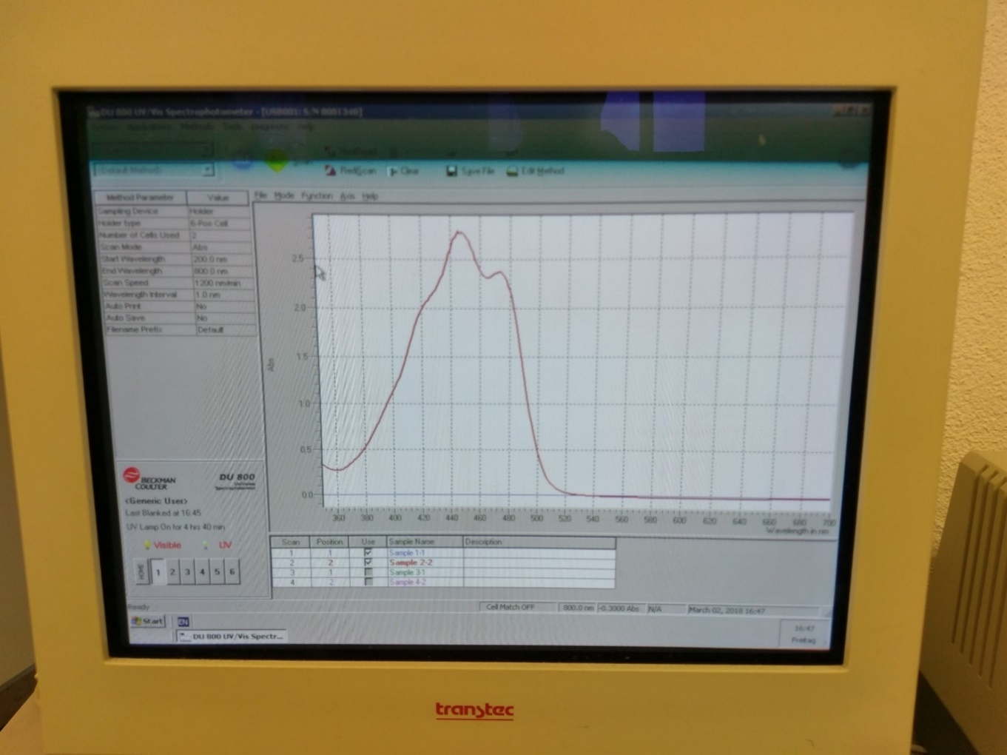

Figure 7: absorption spectra of the photosynthetic pigments [4]

Figure 6: measured absorption spectrum of carotene

Discussion

The photosynthetic pigments were separated by their different affinities for the TLC silica gel plate. The nonpolar carotene did not interact with the plate and therefore migrated the farthest. Chlorophyll b has a CHO group more than chlorophyll a. Therefore, chlorophyll b binds better to the silica gel plate and migrates less far away from the starting point than chlorophyll a. Lutein is the most polar pigment of all four, that is why it binds the best to the plate and migrates the least far.

The measured absorption spectrum of carotene is very similar to the reference[9] one. Both spectra show an absorption until 500 nm and have the same waveform. This means that the measured substance is almost certainly carotene.

## Experiment C31.2, day 1 +2: Systemic gene silencing in *Nicotiana benthamiana* plants

### Introduction [1][2]

Gene expression can be influenced by RNA silencing. This means that, mRNA is transcriptional or post-transcriptional influenced by miRNA or siRNA. The consequence is, that the mRNA cannot be further processed and the protein, for which the mRNA is coding will not be produced. There are many different techniques to achieve a RNA silencing. One possibility is the use of Agrobacterium tumefaciens, which is a soil-borne bacterium. The wildtype (WT) causes the crown gall disease in plants. A horizontal gene transfer mechanism, which leads to silencing of a specific gene, is responsible for this disease. The mechanism can be altered in the labratory. So, other genes of interest can be silenced and the effect for the organism can be studied. Two modified bacteria lines are used in this experiment to silence specific genes. Agrobacterium tumefaciens are able to insert their own DNA into plant cells. The product of inserted DNA is typically siRNA or miRNA, which binds to specific mRNA. The binding leads to the degradation of the mRNA and finally to the above described effects.

### Hypothesis

The GFP-expressing plant, which was infiltrated with the Agro-gffg suspension, will not fluoresces any more. The one which was infiltrated with mock will still fluoresce.

When a WT plant is infiltrated with Agro-TRV-PDS, the leaves are bleached. If it was infiltrated with mock, no change is observed.

### Methods [1]

* each bacteria culture was centrifuged
* supernatant discarded
* pellet resuspended in MgCl2
* because the up and down pipetting was forgotten, the pellet resuspended not at first try. So, about a half of the MgCl2 in the tubes have been removed and then the pipetting was done. Afterwards the tubes were filled up again with MgCl2.
* measured optical density
* because OD600nm < 0.8, the remaining culture wasn’t diluted more
* acetosyringone added (µl 6 acetosyringone to 6 ml bacterial suspension)
* incubated 1 hour at RT
* the two types of plants were infiltrated with mock or an Agrobacterium suspension

Results

**Optical densities:**

Agro-gffg: OD600nm = 0.664

Agro-TRV-PDS: OD600nm = 0.575

The WT plant which was infiltrated with the Agro-TRV-PDS has some bleached areas. The one which was infiltrated with mock does not has any (Figure 1).

The WT plant, which was used as control, is under UV-Light everywhere dark red coloured.

The GPF expressing plant, which was infiltrated with Agro-gffg suspension, shows a dark red colour at the points where the infiltration was performed. The one which was treated with mock does not show any such dark red places.

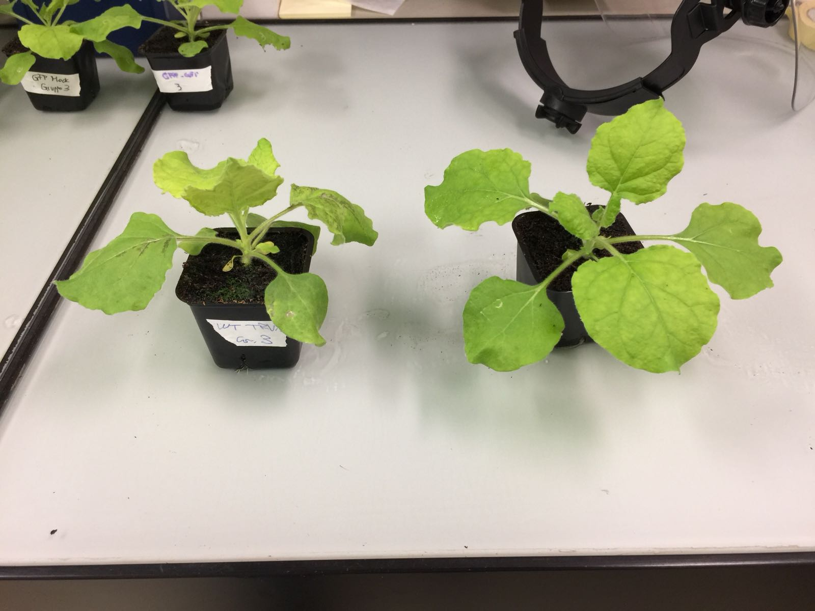

Figure 8: WT plants, on the left side the one which was infiltrated with Agro-TRV-PDS, on the right side the one which was infiltrated with mock

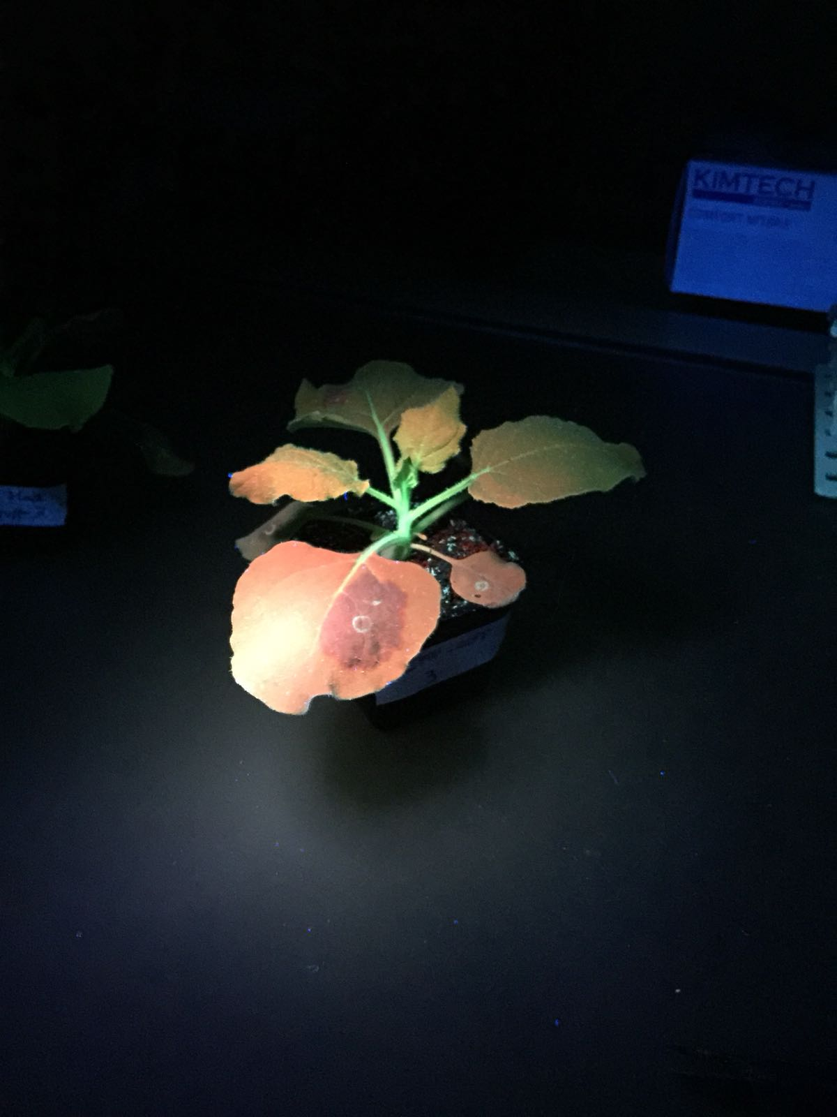

Figure 9: GFP-expressing plant, which was infiltrated with the Agro-gffg suspension

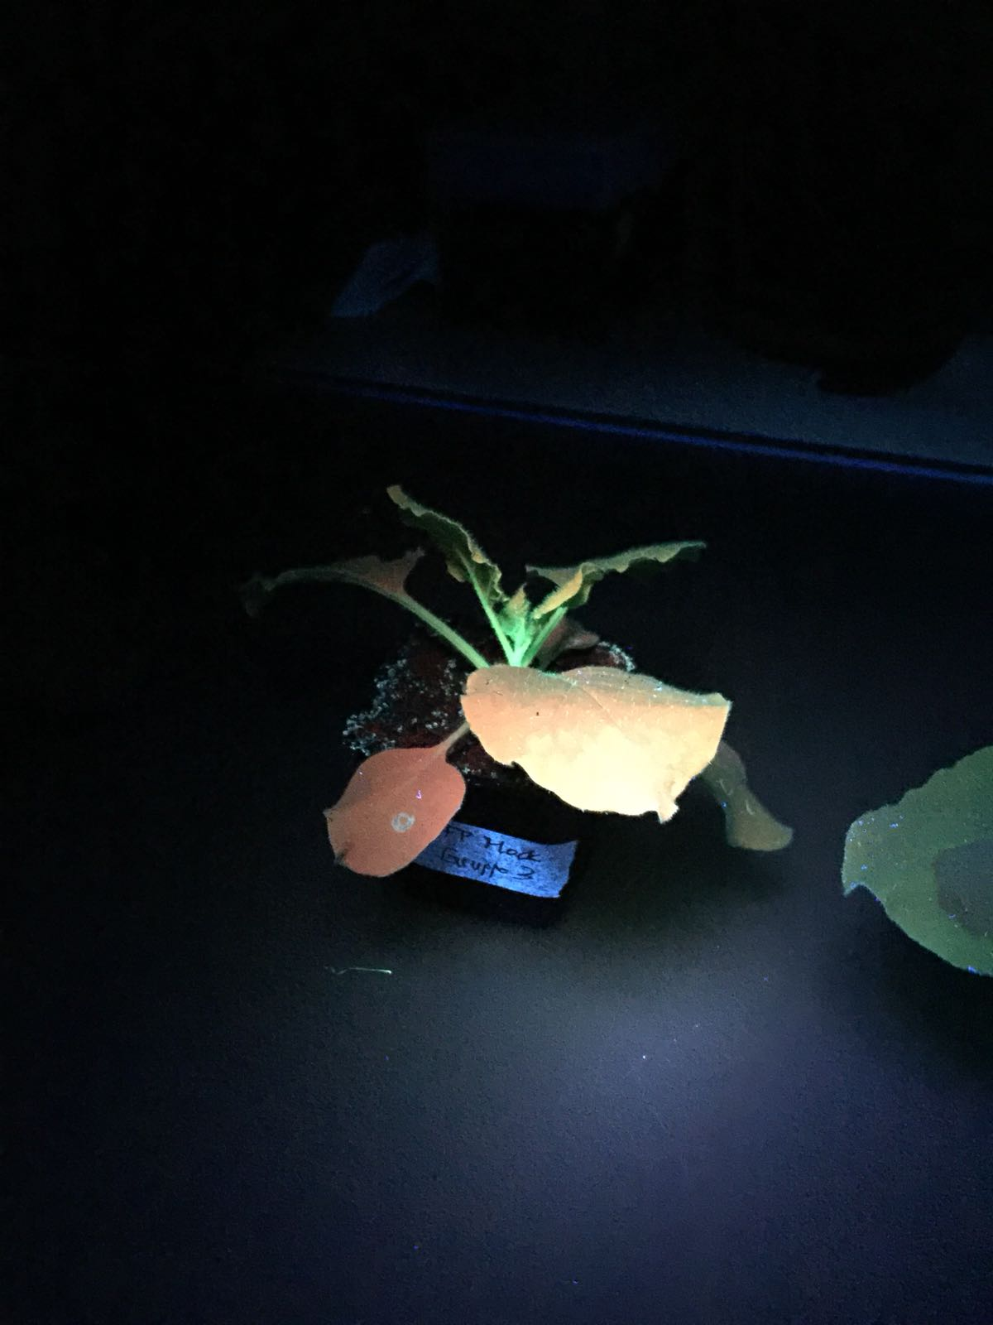

Figure 10: GFP-expressing plant, which was infiltrated with mock

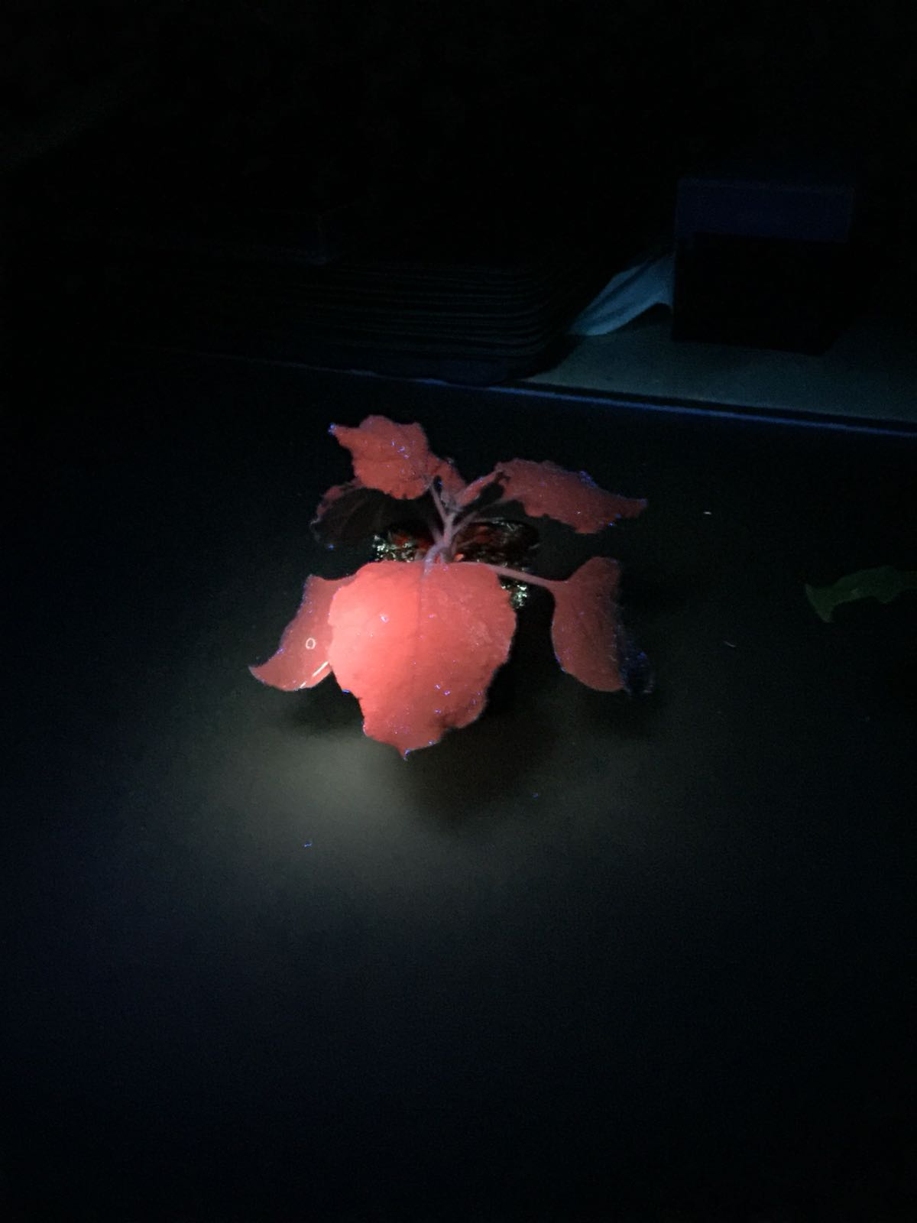

Figure 11: WT plant as control for the observation of fluorescence

Discussion

An explanation for the low optical density without dilution is, that the removed half of the solution of MgCl2 (see methods) already contained some Agrobacteriums, which afterwards were lost. Another explanation is, that the original culture simply had not a higher optical density.

The gene silencing of the GFP plants was successful, because at the places where the Agro-gffg suspension was infiltrated, the green florescence of the GFP was absent. Another important observation is, that a WT plant is under UV-Light totally red. That means, that the highest amount of GFP in the GFP-expressing plants is produced in the stem but also in a smaller amount in the leaves. When the gene is locally silenced, the silenced place appears in the same colour as the WT plant.

The gene silencing of the WT plants was also successful, as shown by the emerged bleached areas in the leaves.

# Experiment C31 day 2:Molecular biology of systemic gene silencing

Introduction[11]

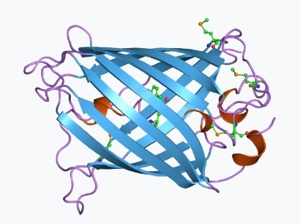The plants, which are used in this experiment are transgenic plants of the genus *Nicotiana*, which contain the green fluorescent protein (GFP) (see figure 12). The transgenic plants can be engineered with the help of *Agrobacterium tumefaciens.* The GFP protein serves as a marker, because under UV-light it is easy to distinguish plants which express GFP from normal plants, thereby allowing to test whether the insertion of the GFP gene worked.   
The aim of this first experiment is to detect the GFP gene. In order to accomplish this goal, a polymerase chain reaction (PCR) is performed.  
The experiment, for the detection of GFP plants requires different setups (for further information, consult the section Methods).   
The aim of the second experiment is to determine the amount of PDS mRNA in normal plants and in gene silenced plants. The experimental setup is very similar to the first experiment. A difference is, however, that in this experiment, complementary DNA (cDNA) is used. The cDNA is produced with a reverse transcriptase, which converts RNA back to DNA. The reason for this step is that DNA is more stable than RNA.

Figure 12: The structure of GFP.

Hypothesis

The hypothesis for the first experiment is that the first and the third tube will not show any amplification of DNA, while the second tube will show an amplification of DNA. The fifth and the sixth tube will show an amplification of DNA, while the seventh tube will not show an amplification of DNA. This hypothesis is based on the fact, that the first tube contains no GFP gene, therefore it cannot be amplified. The second tube contains the GFP gene, which should lead to an amplification. The third tube contains water and no DNA as template. The fifth and sixth tube contains DNA which has the actin gene. This and the Actin PCR mix should lead to an amplification of the gene. The seventh tube contains no DNA.   
The hypothesis for the second experiment is, that the first and the second tube will show an amplification of cDNA. The hypothesis is, that the first tube, which contains the control sample, will show a higher amount of cDNA than the second tube, which contains the cDNA from PDS-silenced tissue. The third tube contains water and no cDNA as template, therefore no amplification is expected.   
The fifth and sixth tube contains cDNA which has the actin gene. This and the Actin PCR mix should lead to an amplification of the gene. The amplified content in the fifth and sixth tube should contain the same amount of amplified cDNA. The seventh tube contains no cDNA.

Methods

Experiment 1:

At first, one leaf of a WT-plant was groundd in a mortar with the addition of 1mL extraction buffer. 0.65 mL of this mixture was transferred to a 1.5mL Eppendorf tube. The tube was then extensively shook and inverted.   
The tube was then incubated for 15 min at 67 °C. It was occasionally inverted. During the incubation, the very same steps were performed with a leaf of a GFP *Nicotiana* plant (GFP-plant).   
It is crucial to prepare the mixture of the WT-plant before the mixture of the GFP-plant, because otherwise the WT extract could be contaminated with GFP DNA. Since we do not expect any result from the tube, which contains PDS PCR mix and WT DNA, the contamination of the GFP tube with WT DNA will not lead to a different 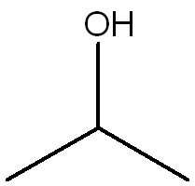outcome, while the contamination of the WT tube with GFP-DNA would lead to an entirely different outcome than predicted (for further information, consult the hypothesis section).   
After the incubation of both tubes, the leaf extracts were then cooled down on ice for about 1 min. Afterwards, 0.35mL of chloroform was added. The tubes were then repeatedly inverted for about 3 min at room temperature (RT).   
Both extracts were then put in an ultracentrifuge for 2 min at 13000 rotations per minute (rpm) at RT.   
During this process, two new 1.5mL Eppendorf-tubes were labeled. 0.5mL of the upper aqueous phase (since chloroform and water do not mix) were pipetted to a respectively labelled Eppendorf-tube without transferring any cell fragments.   
In a next step, 0.35mL of isopropanol (see figure 13) was added to both tubes. The tubes were then mix well but gently and then incubate for about 2 min at RT. DNA precipitates due to the addition of isopropanol and can be separated from molecular impurities. Both tubes were then centrifuged at 13000 rpm for 10 min at RT. In a next step, the supernatant was removed with a pipette.   
After the addition 0.5 mL of cooled 70% ethanol to the DNA pellet, both tubes were gently swirled and centrifuge for 5 min at 13000 rpm at RT. The supernatant was carefully removed and both tubes were left open at RT for a few minutes to dry the DNA pellet. The DNA pellets were then dissolved 0.1mL of deionized water.   
After this step, 0.05mL of the two tubes were transferred to 0.2mL tubes, according to the table in the script, page 25[1].   
The first tube is filled with wild type (WT) DNA, the second tube contains GFP DNA and the third tube is filled with water. All of them contain additionally GFP PCR mix. The fifth tube is filled with wild type (WT) DNA, the sixth tube contains GFP DNA and the seventh tube is filled with water. Those three tubes contain additionally Actin PCR mix.

Figure 13: Figure 13 shows isopropanol. From this structure, the behavior of isopropanol in water is evident.

Experiment 2:

0.05 mL of RNA from Agro-TRV-PDS and 0.05 mL of RNA from the mock plant were transferred to 1.5 mL Eppendorf tubes and mixed with 15µL of RT reaction mix. Both mixtures were centrifuged for approximately 5 seconds and then incubated for 1 h at 40 °C.   
After the incubation period, both tubes were heated up to 70°C for 5 min, subsequently denaturating the reverse transcriptase and therefore inactivate this enzyme.   
After this step, the mixture in both tubes were diluted 5 fold with water.   
After this step, 0.05mL of the two tubes were transferred to 0.2mL tubes, according to the table in the script, page 26[1]. The first tube was filled with mock cDNA, the second tube contained PDS-silenced cDNA and the third tube was filled with water. All of them contain additionally PDS PCR mix. The fifth tube was filled with mock cDNA, the sixth tube contained PDS-silenced cDNA and the seventh tube was filled with water. Those three tubes contained additionally Actin PCR mix.

References

**[1]** Script Practical: Fundamentals of Biology II, plant physiology part, Department of Biology, Institute of Molecular Plant Biology

**[2]** https://de.wikipedia.org/wiki/Chlorophylle#Bedeutung_in_der_Photosynthese

**[3]** Lecture Slides Day 2 C31

**[4]** <http://plantphys.info/plant_physiology/lightrxn.shtml>, accessed 04.03.2018

**[5]** [https://de.wikipedia.org/wiki/Herbizid#Breitbandherbizide](https://de.wikipedia.org/wiki/Herbizid" \l "Breitbandherbizide)

**[6]** <https://de.wikipedia.org/wiki/Norflurazon>

**[7]** Wolff P.; Ottenschläger I.; Palme K. Auxin-Signaltransduktion bei Pflanzen Biospektrum 2003, 5, 577 – 580

**[8]** http://www.chemie.de/lexikon/Auxine.html, accessed 24.02.2018

**[9]** https://de.wikipedia.org/wiki/Erbse, accessed 24.02.2018

**[10]** Santner A.; Calderon-Villalobos L. I. A.; Estelle M. Plant hormones are versatile chemical regulators of plant growth Nature Chemical Biology **2009**, 5, 301-307

**[11]** <https://en.wikipedia.org/wiki/Green_fluorescent_protein>